1. Install nginx and run nginx on port number 81.

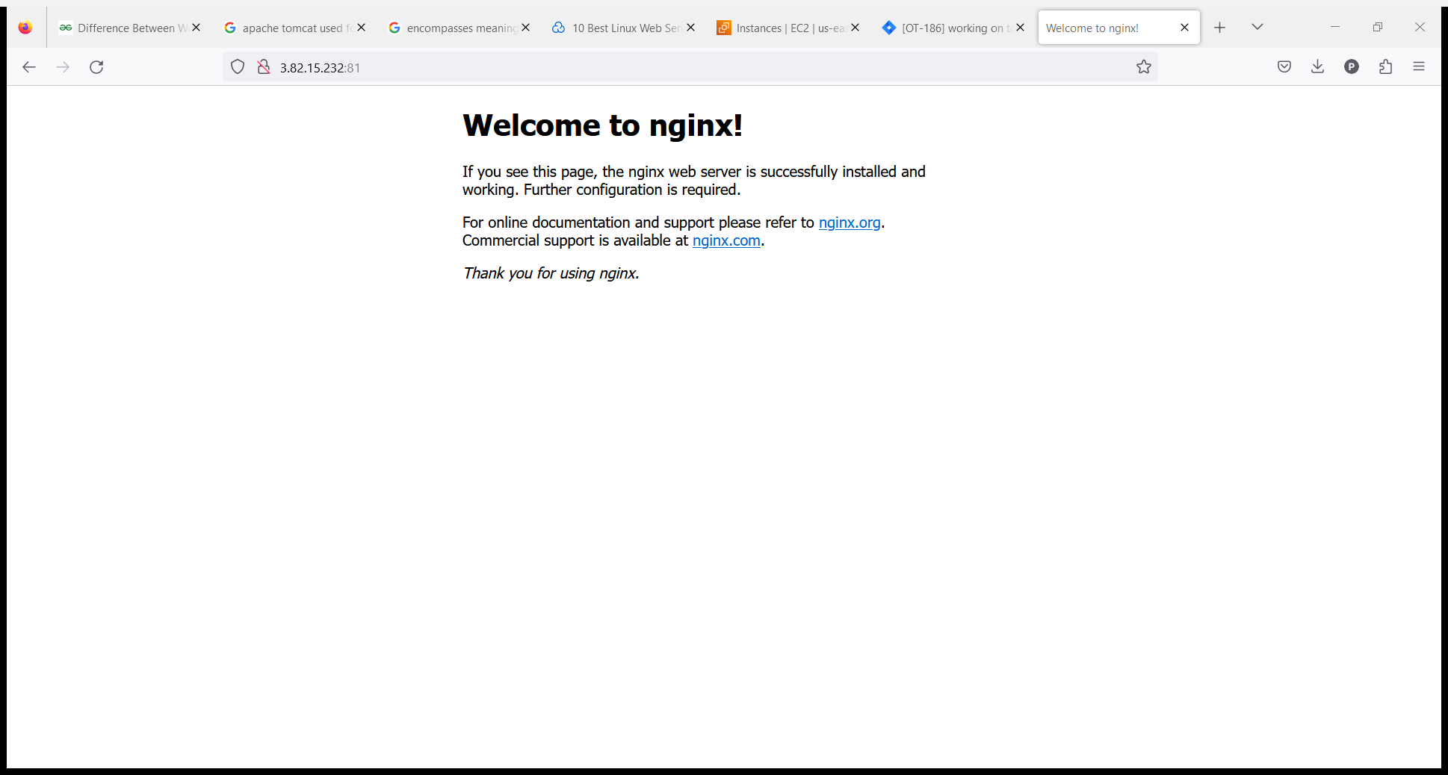

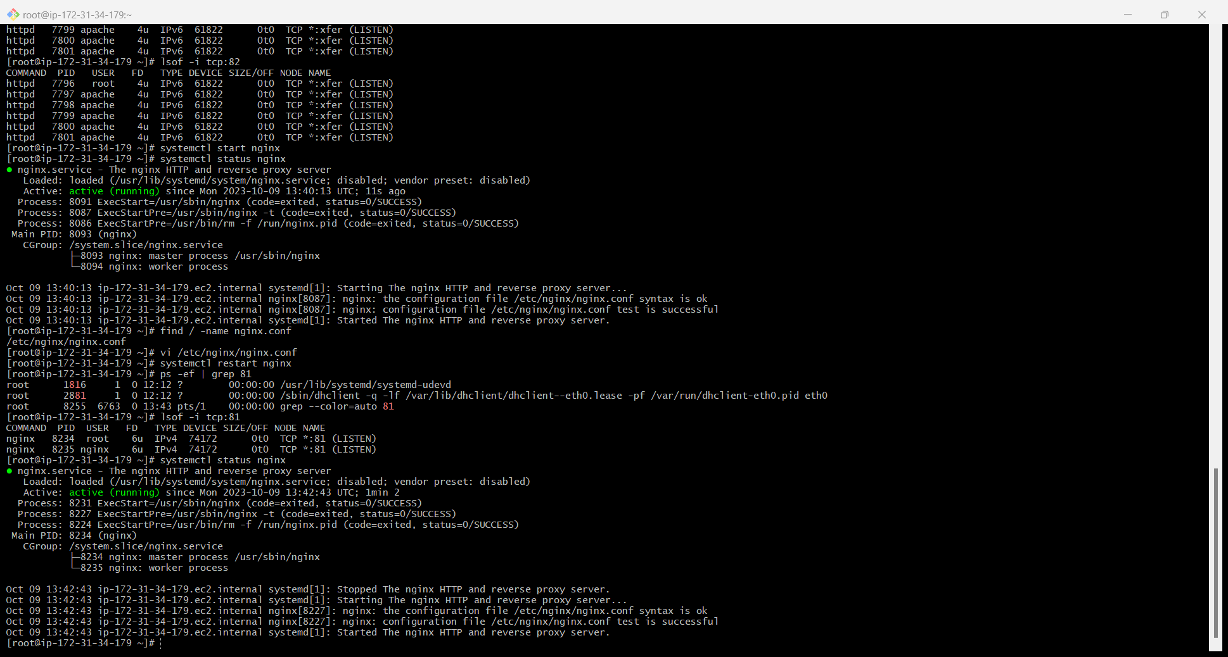

1. Deploy a sample index.html file on nginx.

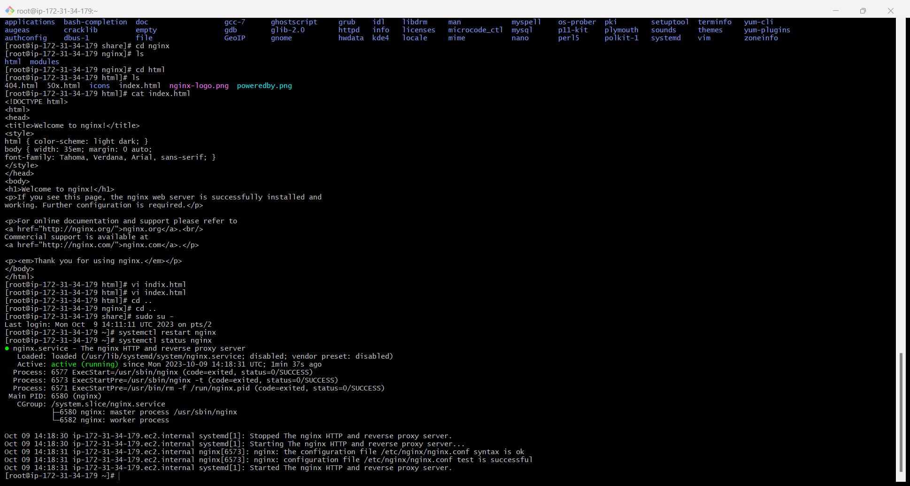

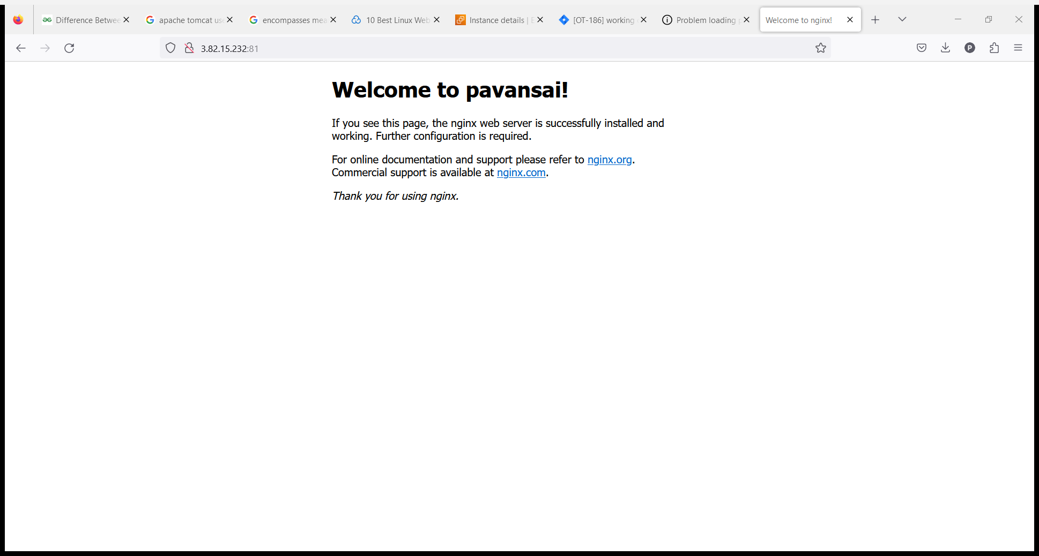

3) Install Apache and run Apache on port number 82

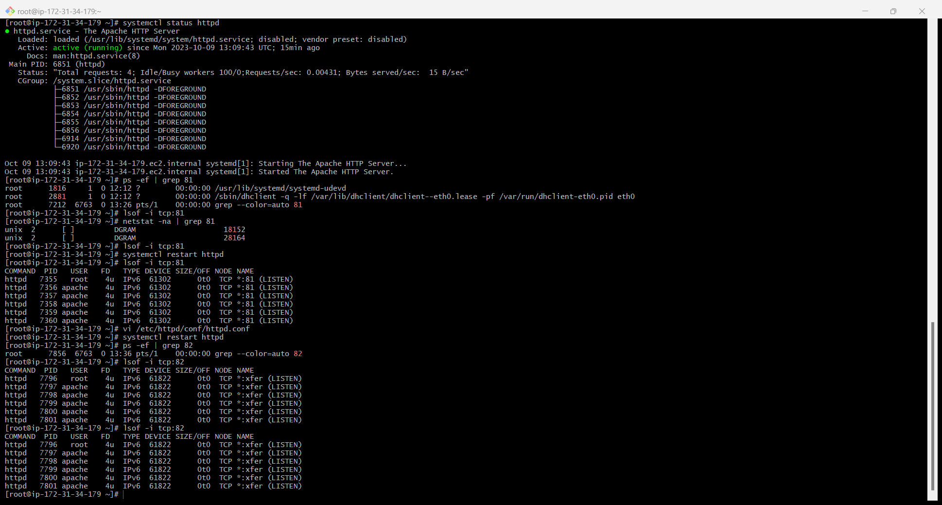

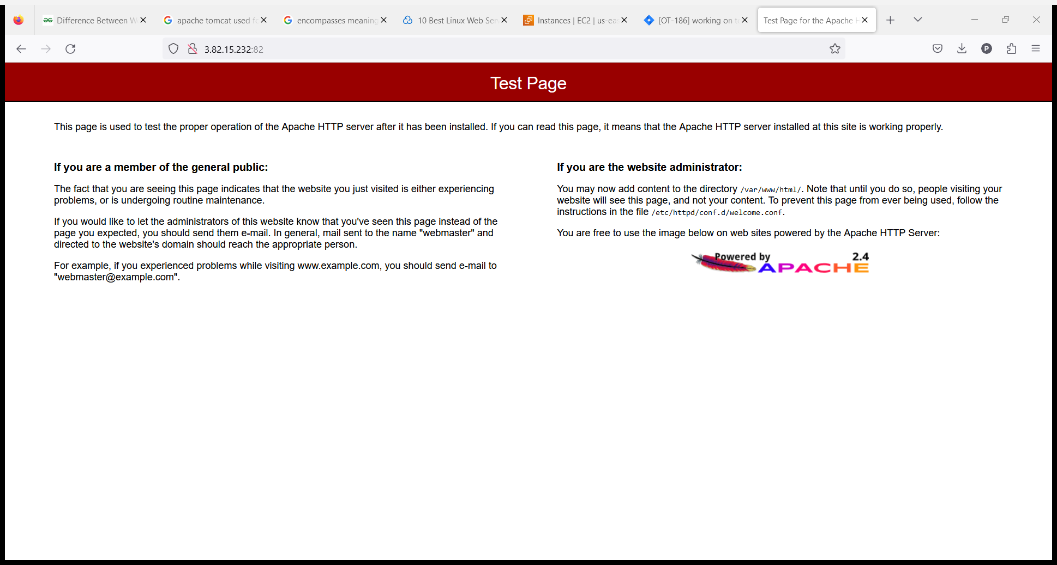

1. Deploy a sample index.html file on Apache.

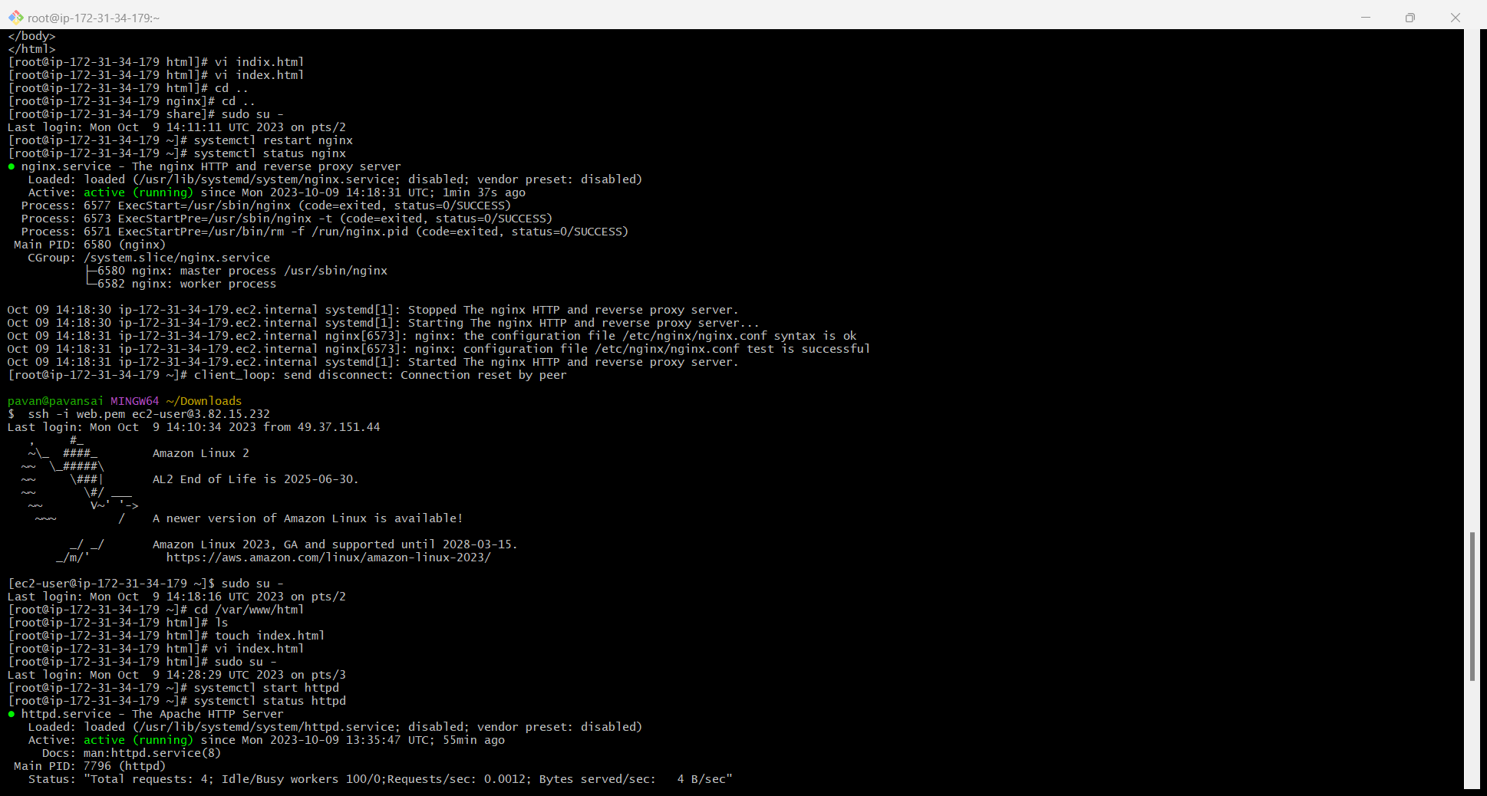

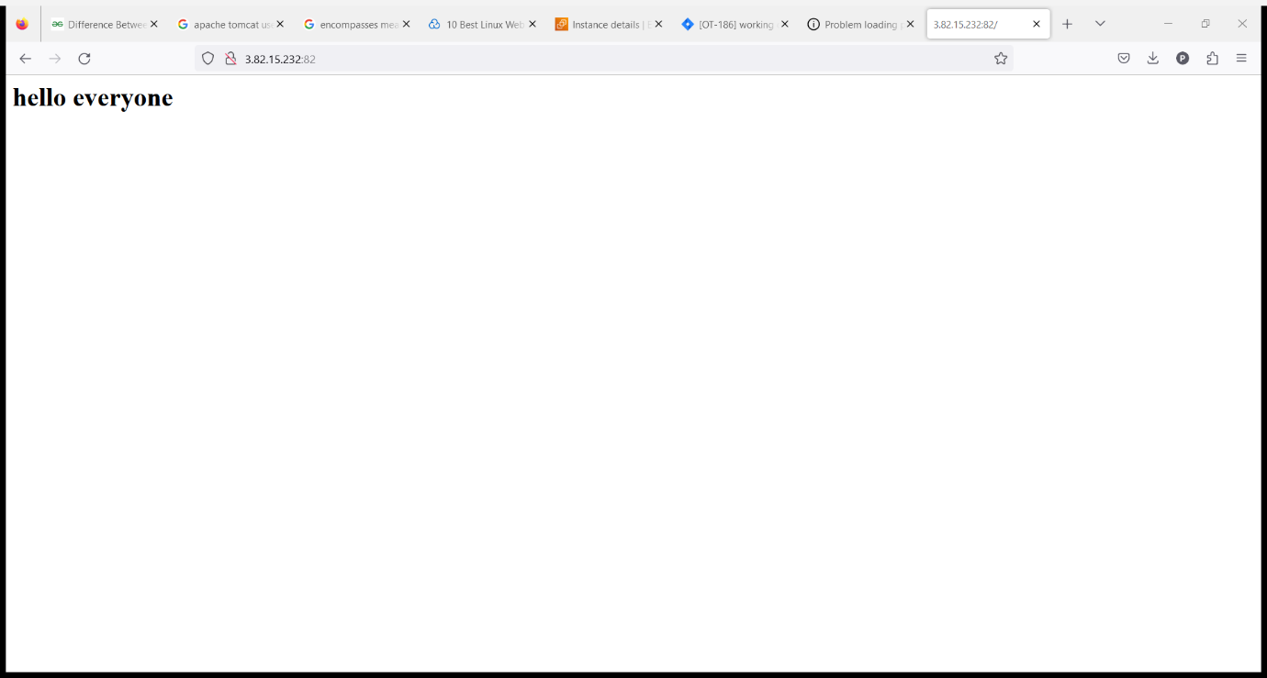

1. Install Apache tomcat on port number 8082

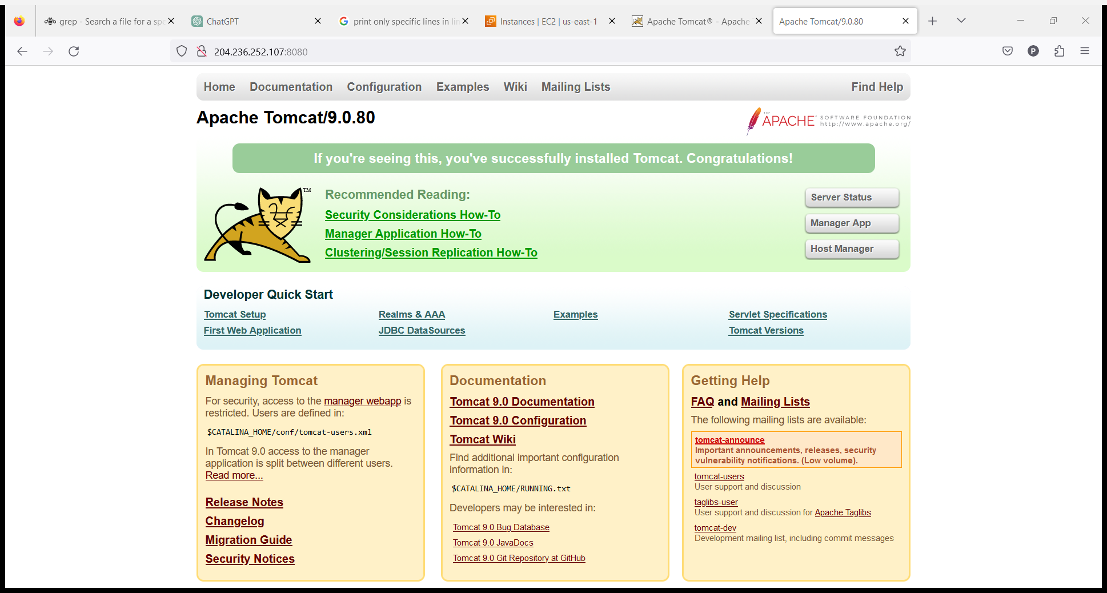

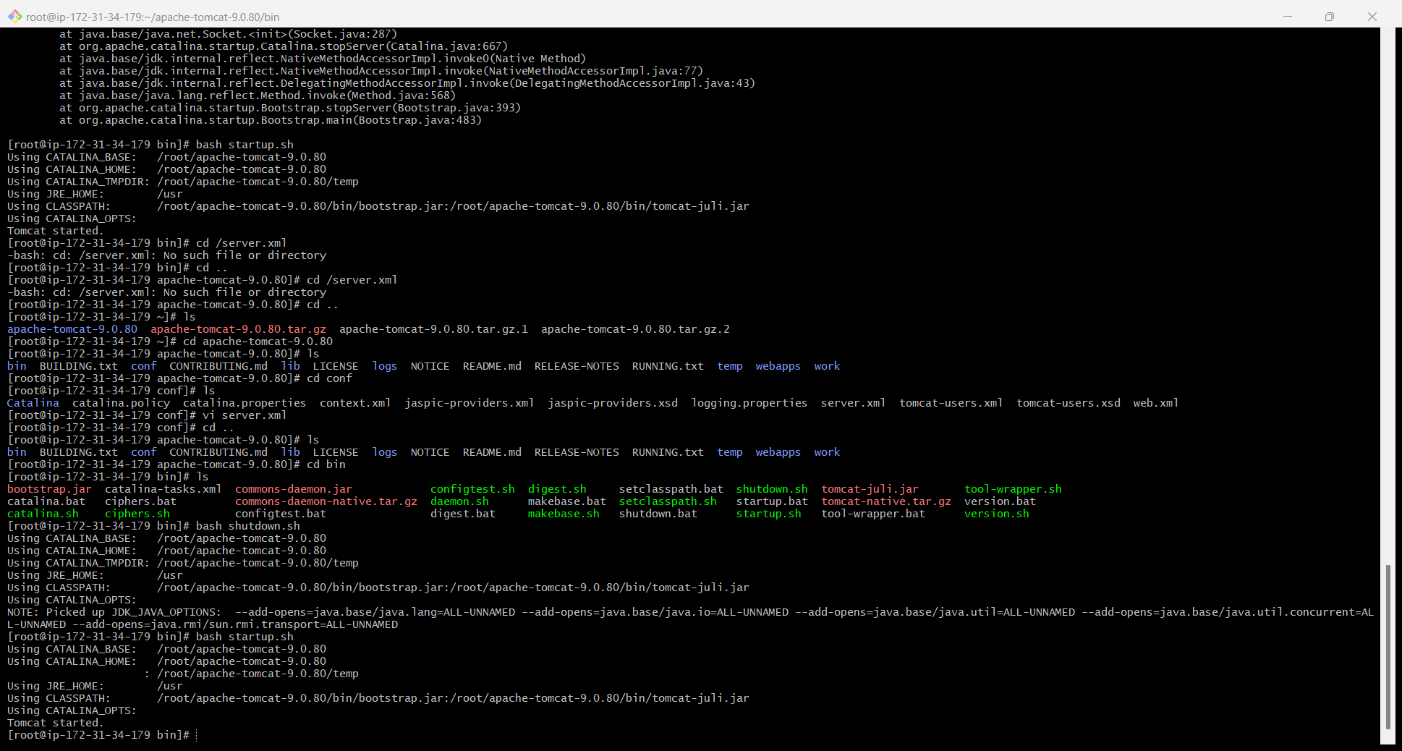

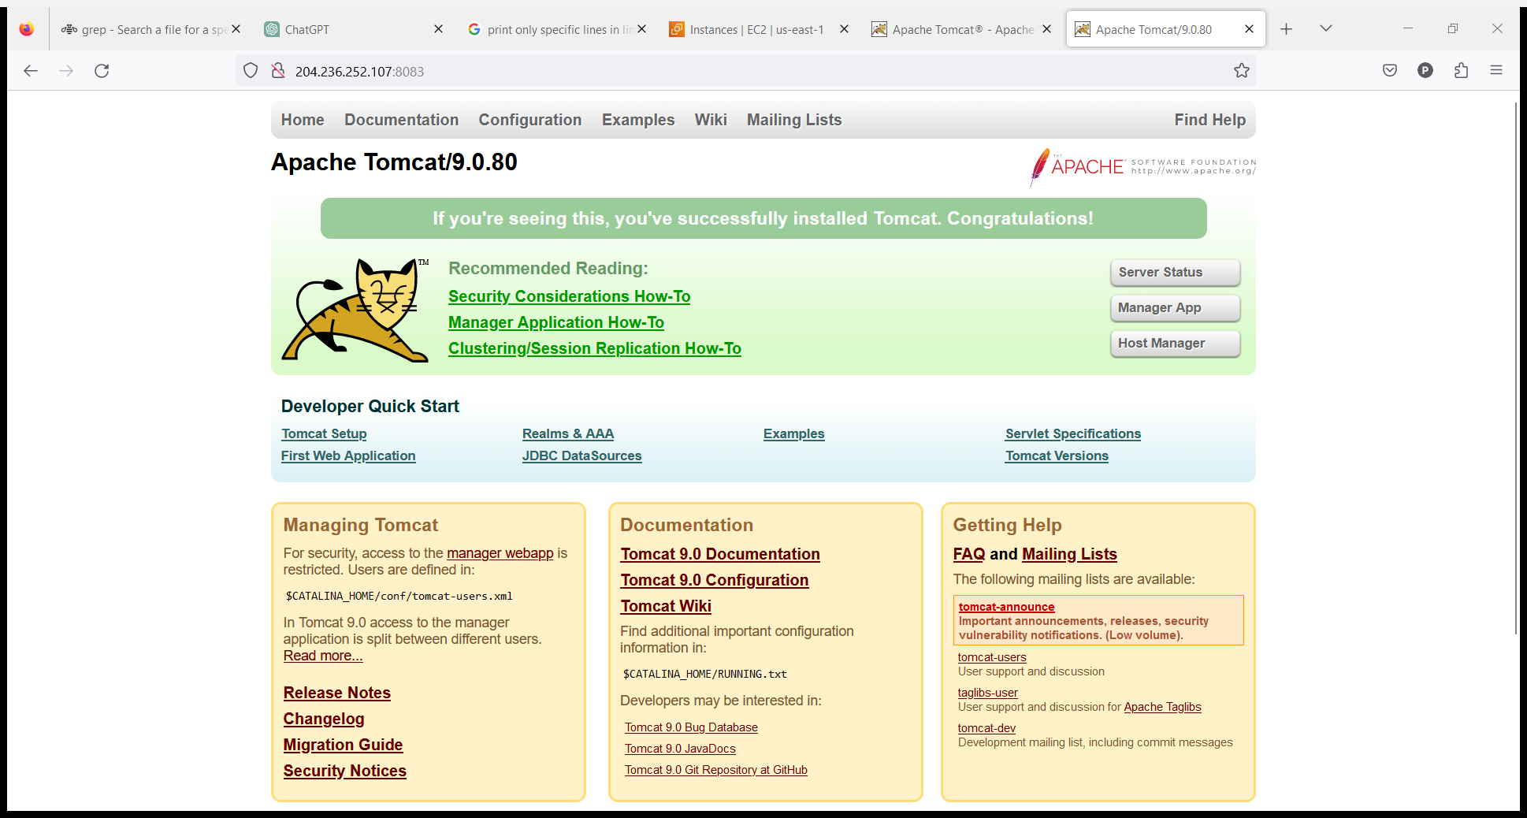

1. Deploy a sample app on webapps

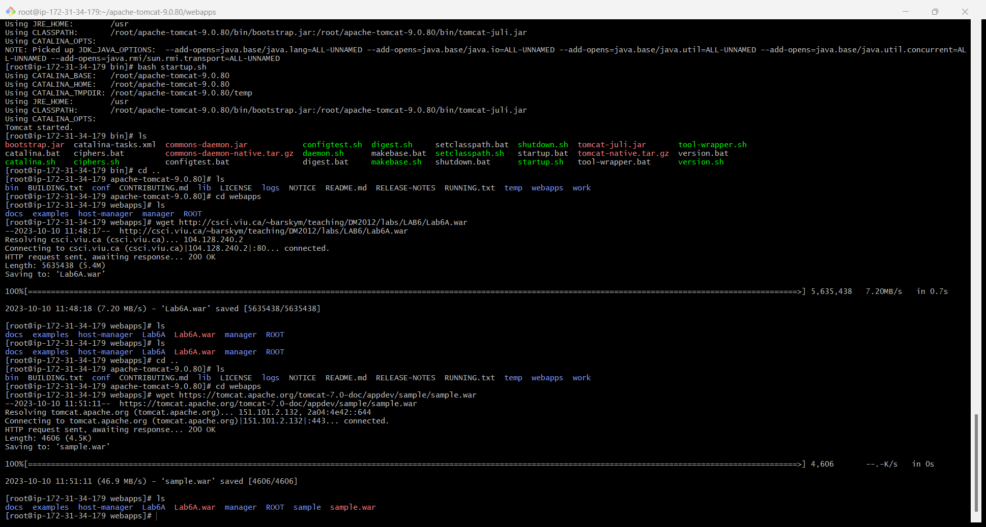

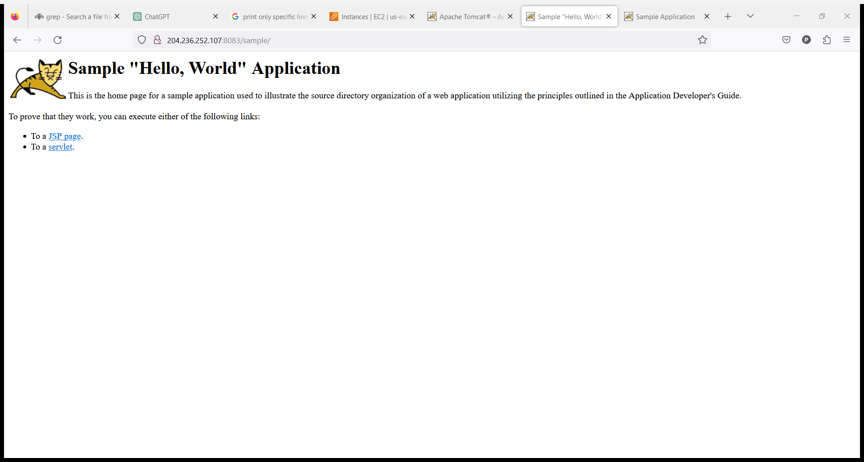

1. Create a tomcat.service file for tomcat.

First install tomcat

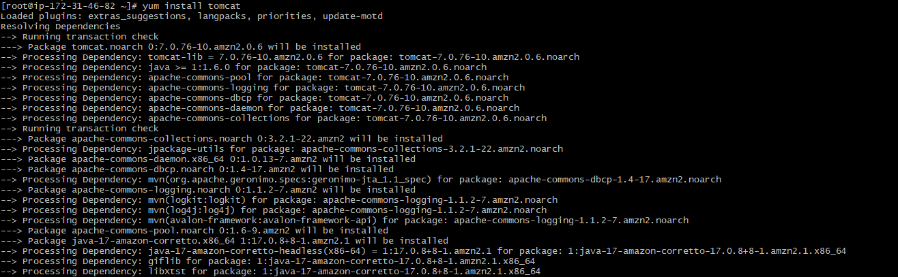

Add tomcat.service file in the below location



Add the below content

[Unit]

Description=Tomcat - instance %i

After=syslog.target network.target

[Service]

Type=forking

User=root

Group=root

ExecStart=/opt/apache-tomcat-9.0.78/bin/startup.sh #check the path of startup.sh

ExecStop=/opt/apache-tomcat-9.0.78/bin/shutdown.sh #check the path of shutdown.sh

RestartSec=10

Restart=always..

Then Restart Daemon

Command is systemctl daemon-reload



Then Start tomcat using systemctl.

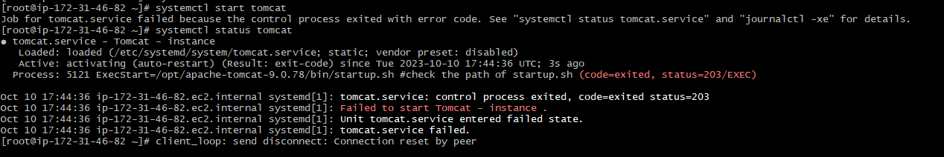

8) Configure HA Proxy server

**Launching 3 EC2 instances for httpd, nginx and haproxy**

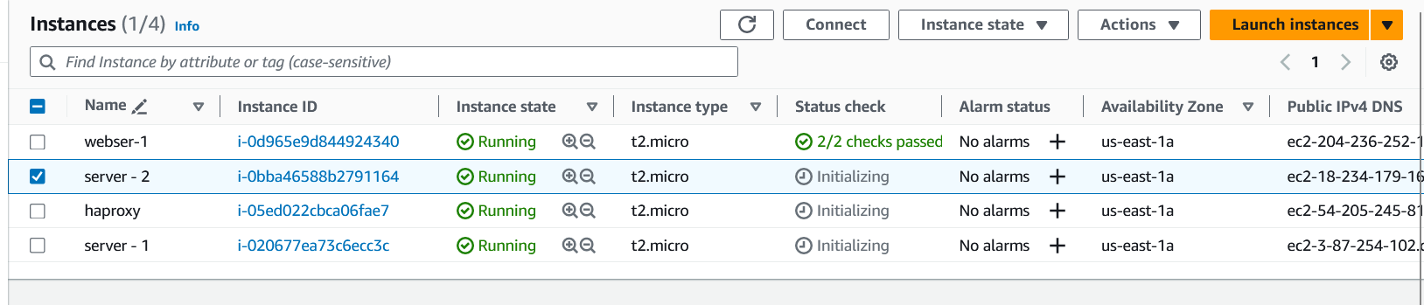

**Install httpd in one server that named it as server-1 , start and status of httpd**

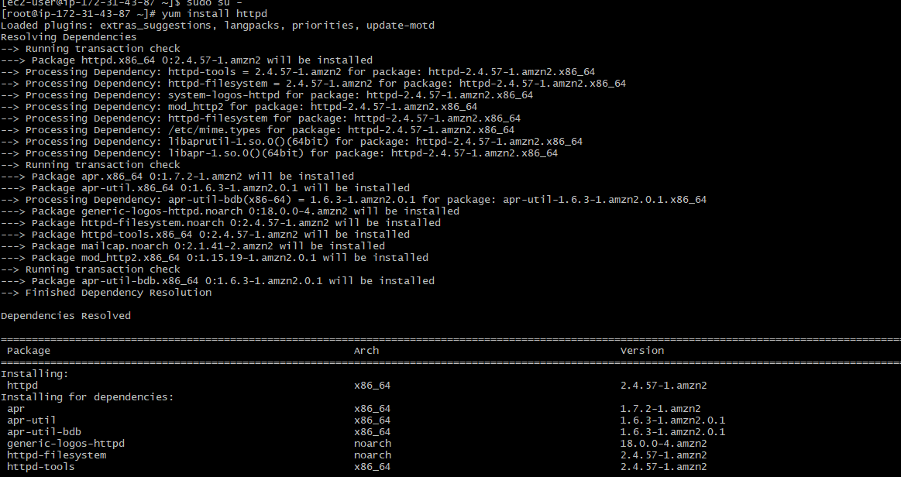

**Create sample index.html file**



**Now go to cd /etc**



**Then go to vi hosts and give HA proxy server public ip address and ping the load balancer**

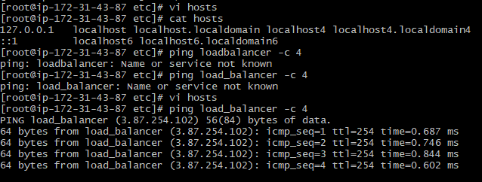

**Again restart and check status of httpd**

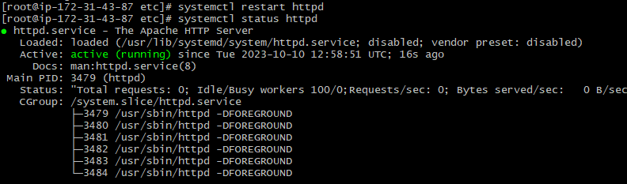

**Now go to server-2**

**Install nginx, start and check status**

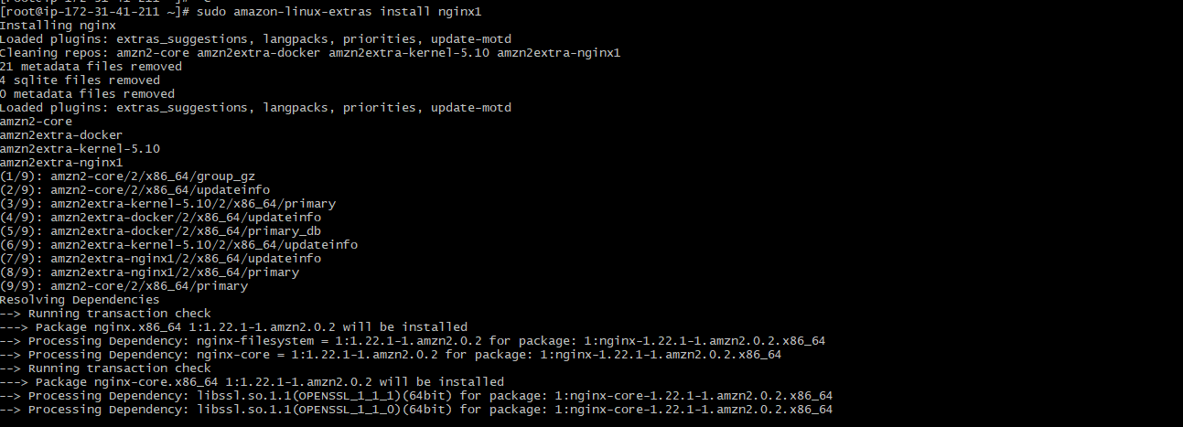

**Here create a index.html code as same as httpd but here command is echo “hello world” > /usr/share/nginx/html/index.html**



**Go to cd**



**Now go to vi hosts give public ip address of HAproxy**

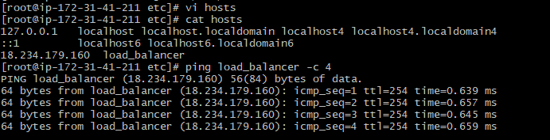

**Ping load balancer**

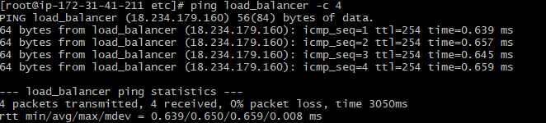

**Again restart and check status of nginx**

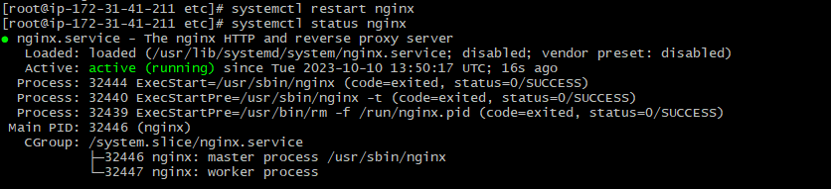

**Now come to HA proxy server like our server-3**

**Install HAproxy and start and check status**



**Cd /etc**



**Vi hosts and give server-1 and server-2 public ip address**

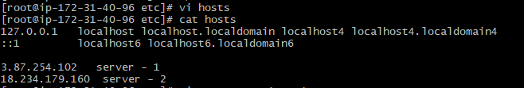

**Ping server - 1**

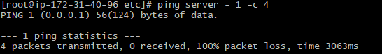

**Ping server -2**

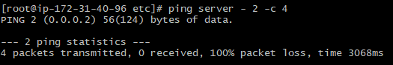

**Cd haproxy**



**Create back up of haproxy.cfg**



**Vi haproxy.cfg**



**Here give port number 80 in main frontend and give public ips of server-1 and server-2 in backend in the same file**

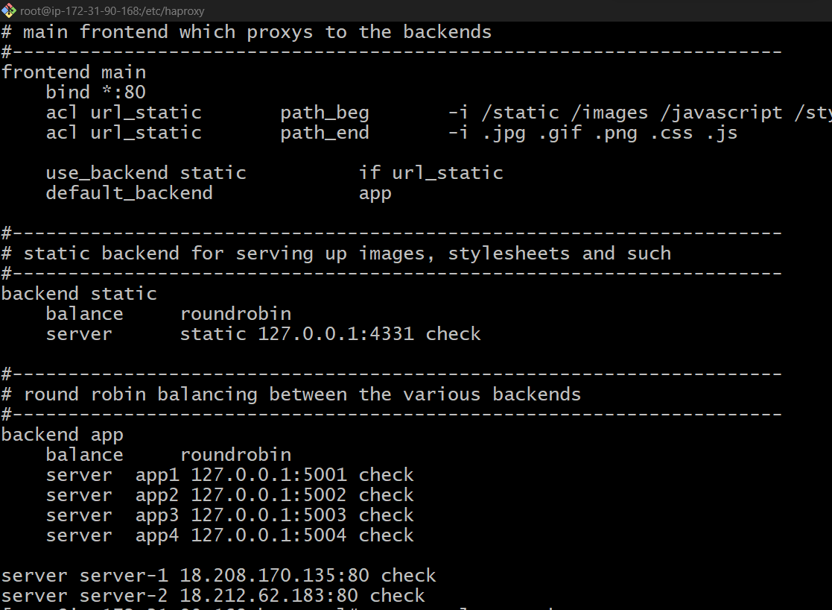

**Again restart and check status**

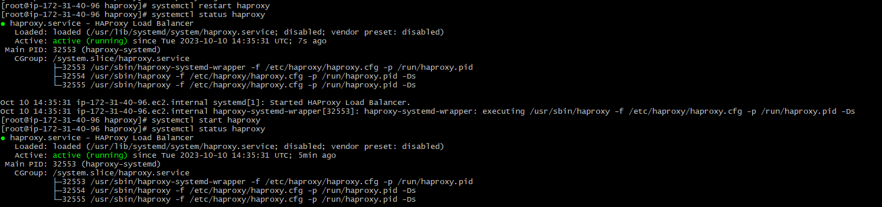

**Here the result take ip address of ha proxy and browse**

